EXPERIMENT 4

4.Write a C program to check whether a given string belongs to the language defined by a Context Free Grammar (CFG)

S → 0S0 | 1S1 | 0 | 1 | ε

# AIM:

To Write a C program to check whether a given string belongs to the language defined by a Context Free Grammar (CFG)

S → 0S0 | 1S1 | 0 | 1 | ε

# APPARATUS:

DEV C++

# ALGORITHM:

1. Get the input string from the user.

2. Find the length of the string. Let it be n.

3. Check whether all the symbols in the input are either 0 or 1. If so, print “String is valid” and go to step 4. Otherwise print “String not valid” and quit the program.

4. If the 1st symbol and nth symbol are the same, 2nd symbol and (n-1)th symbol are the same and so on, then the given string is palindrome. So, print “String accepted”. Otherwise, print “String not accepted”

# C PROGRAM:

#include<stdio.h>

#include<string.h>

int main()

{

char s[100];

int i,flag,flag1,a,b;

int l;

printf("enter a string to check:");

scanf("%s",s);

l=strlen(s);

flag=1;

for(i=0;i<l;i++)

{

if(s[i]!='0' && s[i]!='1')

{

flag=0;

}

}

if(flag!=1)

printf("string is Not Valid\n");

if(flag==1)

{

flag1=1;

a=0;b=l-1;

while(a!=(l/2))

{

if(s[a]!=s[b])

{

flag1=0;

}

a=a+1;

b=b-1;

}

if (flag1==1)

{

printf("The string is a palindrome\n");

printf("string is accepted\n");

}

else

{

printf("The string is not a palindrome\n");

printf("string is Not accepted\n");

}

}

}

# OUTPUT:

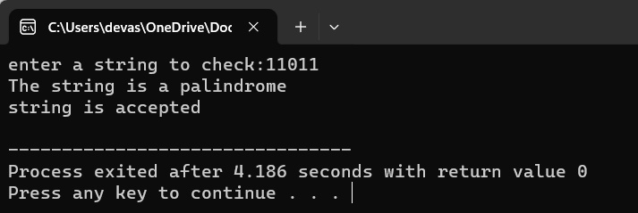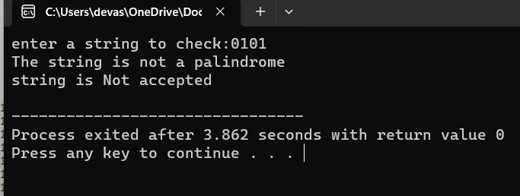

# RESULT:

Thus the C program is executed successfully and verified the string